# DELHI TECHNOLOGICAL UNIVERSITY

**PROJECT REPORT**





Submitted to Submitted by

Mr. Rajeev Kumar Ritik Singh (2K19/CO/319)

**DELHI TECHNOLOGICAL UNIVERSITY**

(Formerly Delhi College of Engineering)

Bawana Road, Delhi – 110042



**CERTIFICATE**

This is to certify that the report entitled “**Android Application for Online Medical Consultancy**” is a Bonafide work carried out by **Mr. RITIK SINGH (2K1/CO/319)** under the guidance and supervision of **Mr. Rajeev Kumar** for the subject **CO301** | **Software Project** (CSE) of 5th Semester of Bachelor of Technology in **DTU .**

To the best of my knowledge and belief, this work embodies the work of candidate himself, has duly been completed, and fulfills the requirement of the ordinance relating to the B.Tech. Degree of the University and is up to the standard in respect of content, presentation and language for being referred to the examiner.

**Delhi Technology University At: Bawana Road, Delhi**

**Abstract**

This project is based on the Mobile Application for Online Consultancy for people all around the world. This App basically allows us to Consult ourselves while sitting at our Home.

From this application, a user can input their Symptoms and can get a list of Diseases that they can have and provides basic Information regarding that Diseases. It also provides link for more Information. Also provides Option for finding nearby Hospitals and Emergency Calls.

**Acknowledgement**

I am privileged to have this opportunity to express my gratitude and acknowledge

to everyone’s never ending support and valuable contributions for my project.

I would like to express my sincere gratitude to my advisor Mr. Rajeev Kumar for the continuous support to my project and project related research, for her patience, motivation, and immense knowledge.

My sincere thanks also go to Mr. Rajeev Kumar who provided me an opportunity to work on a project and to be able to present the same.

At last, I thank my parents and friends for their constant encouragement without which this project would not have been possible.

My thanks and appreciation also go to my colleagues in developing the project and people who have willingly helped me out with their suggestions and abilities.

|  |  |  |
| --- | --- | --- |
|  | **Abstract** | **I** |
|  | **Acknowledgement** | **II** |
| **1.** | PROJECT DEFINITION | **3** |
| **2.** | PROJECT MANAGEMENT | **5** |
| **3.** | SYSTEMS REQUIREMENTS | **6** |
| **4.** | SYSTEM DESIGN AND ANALYSIS | **7** |
| **5.** | SCREENSHOTS | **9** |
| **6.** | LIMITATIONS AND FUTURE ENCHANCEMENT | **18** |
| **7.** | CONCLUSION AND DISCUSSION | **19** |
| **8.** | REFERENCES | **20** |

**INDEX**

**Chapter 1: PROJECT DEFINITION**

* 1. **Project Summary**

This Project is entitled as Medical Expert. As the name itself suggest it is a Medical App. It takes Symptoms as user’s inputs and displays the list of Diseases as per priorities based on list of Symptoms provided by User.

* WELCOME PAGE
* HOME PAGE
  + Name
  + Age
  + Gender
* DISEASE CHECKER
  + Entering the Symptoms
  + Displaying of Diseases
  + Link for Detailed Information
* NEARBY HOSPITALS
* SOS CALL
  + Enter Number
* CONTACT US
  + Call
  + Mail
  + Location

* 1. **Purpose**

As we know in today’s rush it is difficult to take a Doctor’s appointment in Emergency. So, what to do until we get an appointment with Doctor. That’s where this App’s comes into the action. A user can input their Symptoms and can get a list of Diseases they may poses.

* 1. **Scope**

With the help of this application one can prevent their Diseases from spreading more. This can save someone’s Life who cannot reach to the Doctor in case of Emergency. They can at least take some action for preventing their Disease.

* 1. **Objective**

The main objective of this application is to help people to cure them and save their Time, Money and Resources, and save their Lives as well.

**Chapter 2: PROJECT MANAGEMENT**

* 1. **Project Planning**
     1. **Project Effort and Time**

The developer had given about 3-4 hours per week to make this project.

* + 1. **Roles and Responsibilities**

He had worked effectively and have undertaken the following tasks:

* + - * Researching in the related field of Diseases
      * Creating a Design of flow
      * Connecting to Google Maps
      * Coding the logic
      * Make UI for application
      * Testing the application for runtime errors and bugs
      * Fixing the Bugs
      * Concluding the code and hence the project

**Chapter 3: SYSTEMS REQUIREMENTS**

* 1. **User Characteristics**

The application has been made very user friendly with basic Interface. Application is well organized with attractive UI. The UI is very simple and easy to use and understand.

* 1. **Hardware Requirements**
     + Processor: i3/i5/i7 8gen or above
     + Processor Speed: 2.16GHZ or above
     + RAM: 3 GB RAM or above
     + Storage: 20 GB hard disk or above
     + 1280 X 800 MINIMUM SCREEN RESOLUTION

* 1. **Software Requirements**
* Android Studio 3.4/3.5
* Adobe XD
* JDK 11.0.1

**Chapter 4: SYSTEM DESIGN AND ANALYSIS**

For developing an Android Application, I’ve used Android Studio software. It is an open source software. I’ve designed UI in Android Studio using XML.

**4.1 Installing Android Studio**

Android Studio is an open source software. You can download and set up it from the official website. After installing Android Studio, you have to setup the path for SDK and download the desired API and desired emulator to test your application.

**4..2 Creating UI**

You can design UI using XML in Android Studio. To create attractive UI, you can also use Adobe XD.

**4.3** **Major Functionalities**

This project includes main 3 functions:

* Symptoms Checker
* Nearby Hospitals
* SOS Call
  1. **Flowchart**

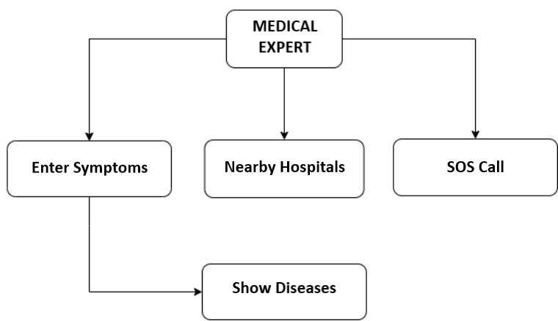

**Chapter 5: SCREENSHOTS**

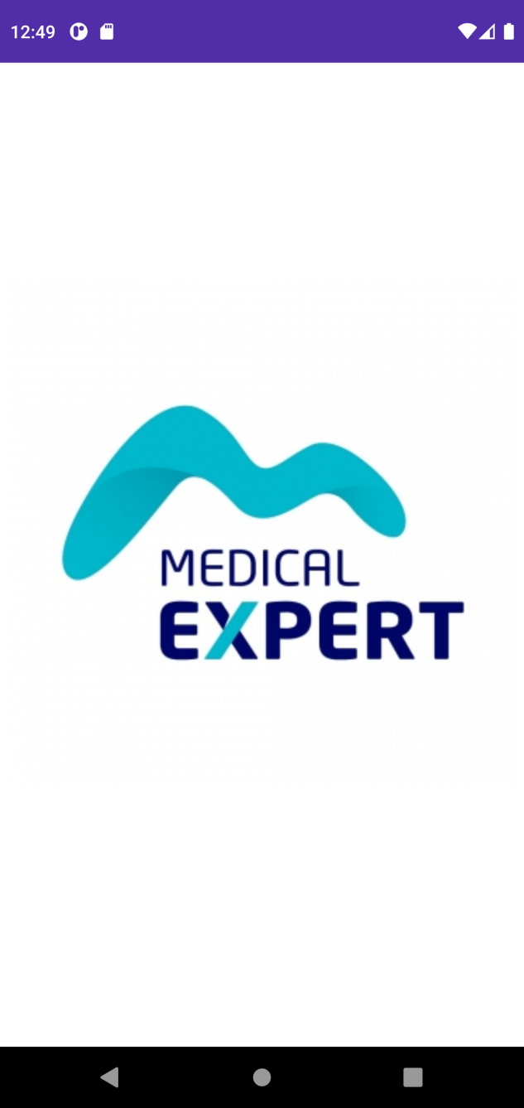

**5.1 Welcome Page**

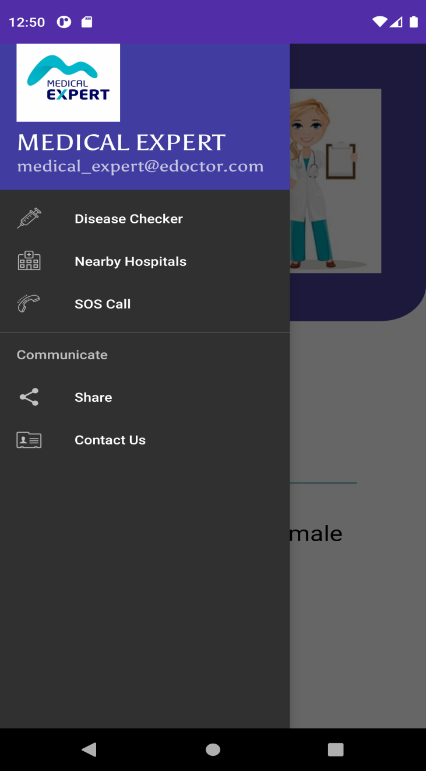 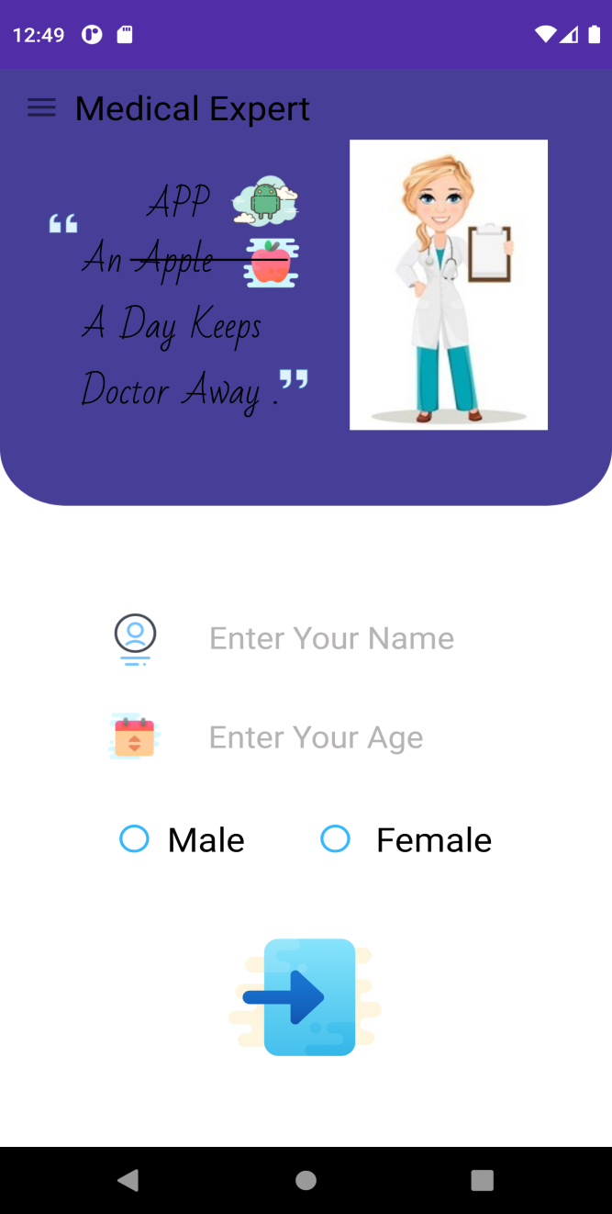

**5.2 Home Page**

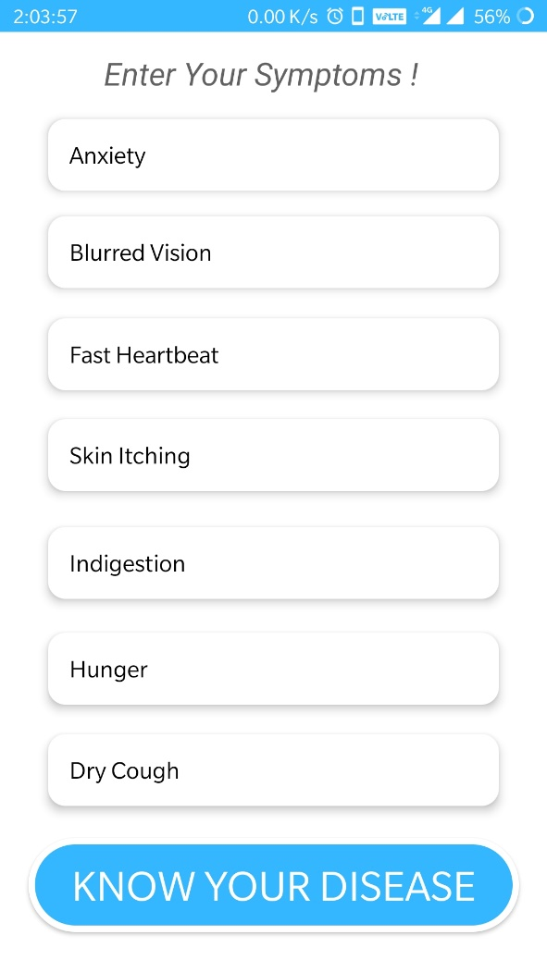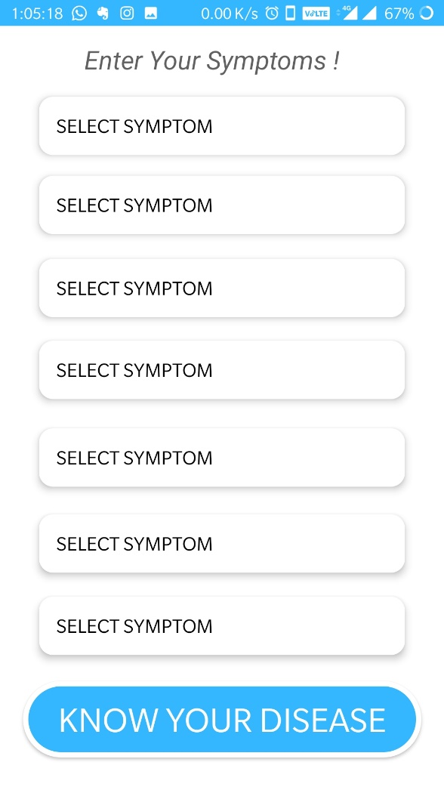

**5.3 Disease Checker**

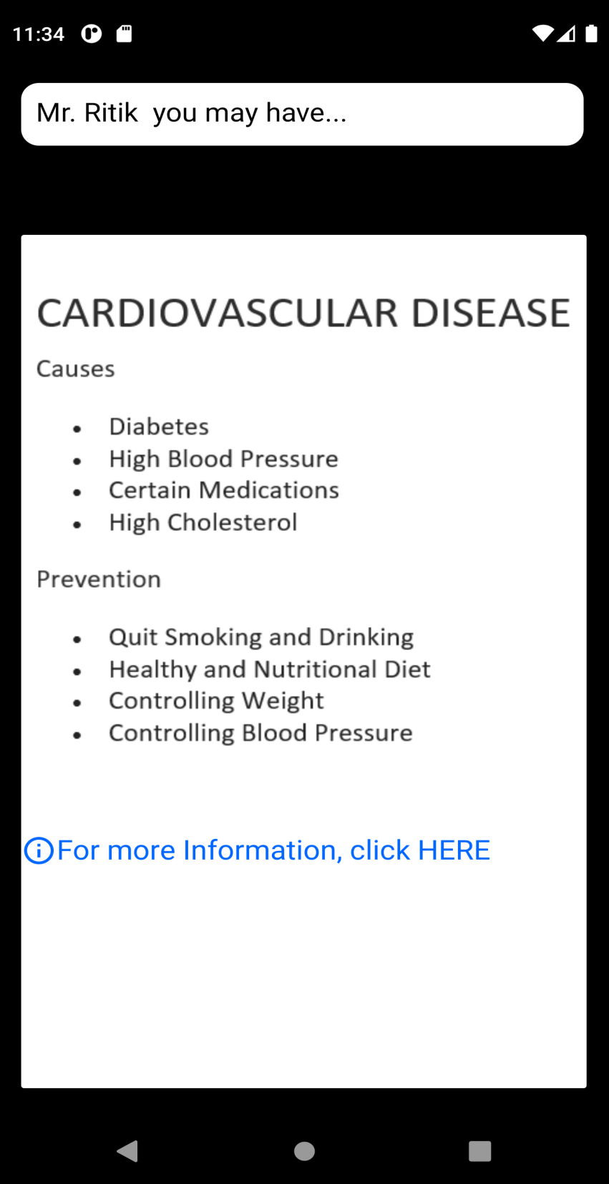

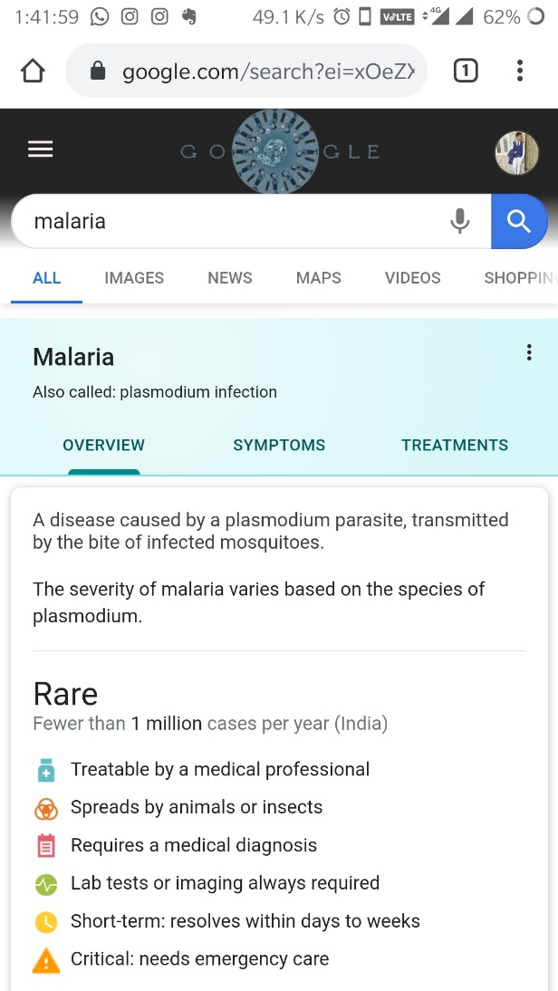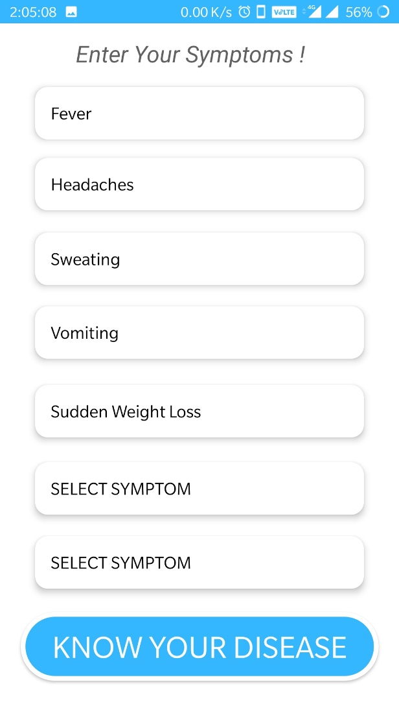

**5.4 Nearby Hospitals**

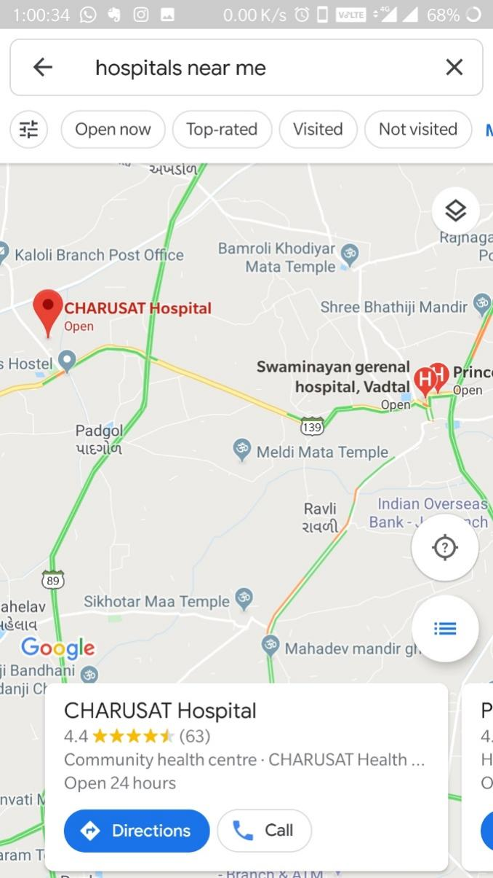

**5.5 SOS Call**

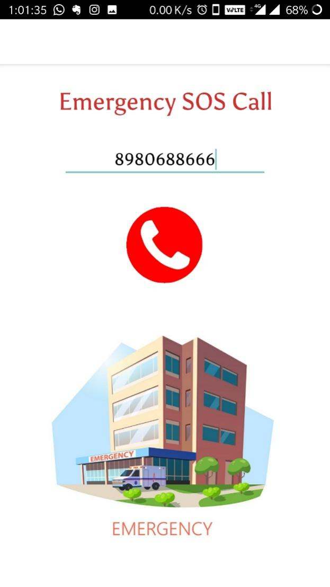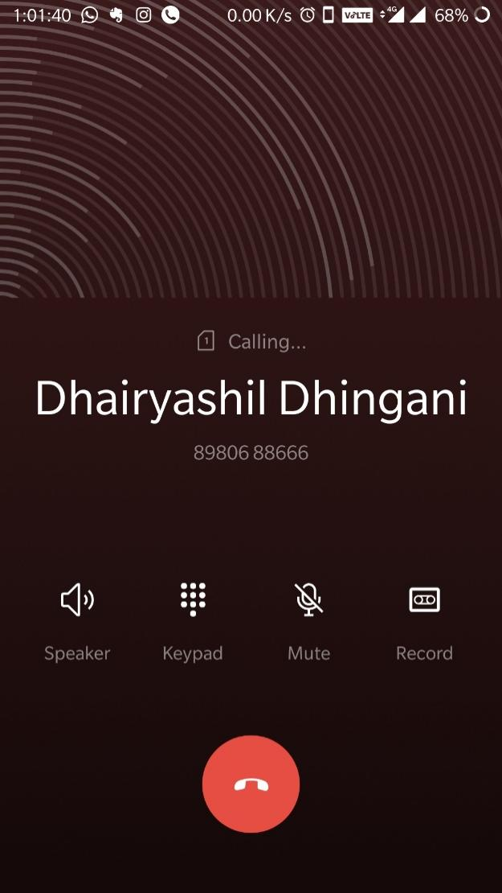

**5.6 Share**

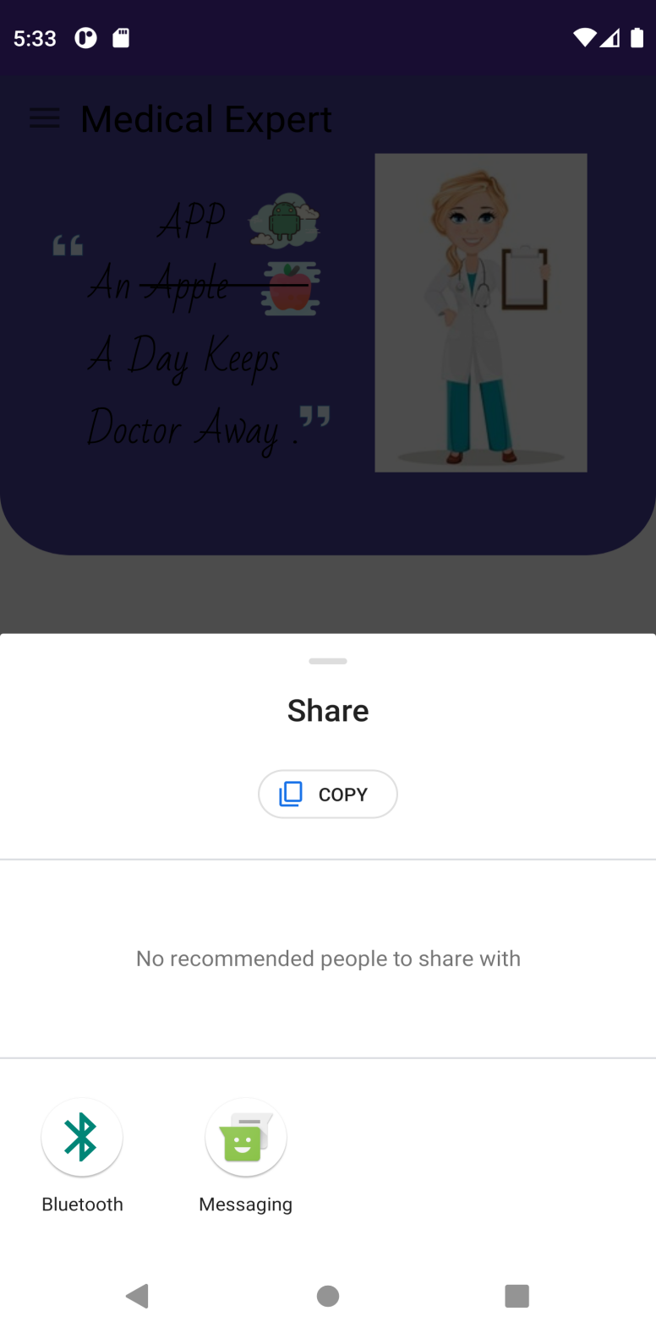

**5.7 Contact Us**

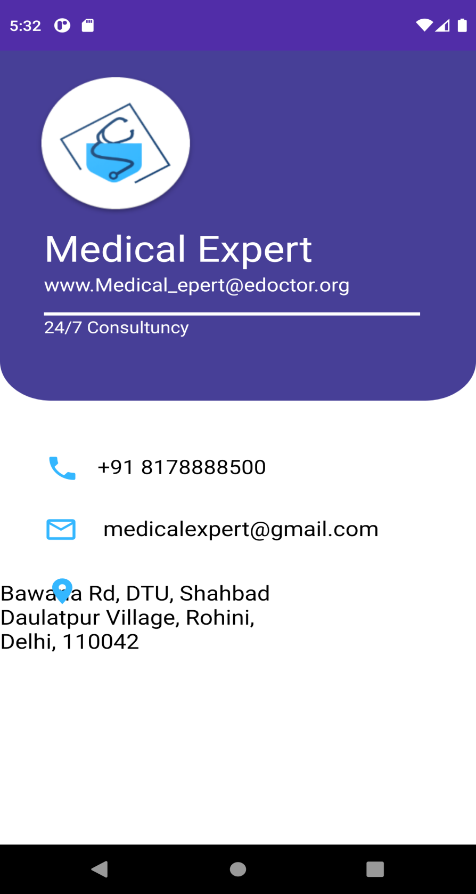

**Chapter 6: LIMITATIONS AND FUTURE ENHANCEMENT**

* 1. **Limitations**

Following are the currently persisting limitations in the application:

* Does not Cover up all the Diseases, as it will need ML as well as large Database.
* We have just prepared a Prototype.
  1. **Future Enhancements**

Following are some aspirations specifying our future enhancements:

* To Obtain Information and contact details of Doctor concerned to your Disease.
* To Cover Up All the Diseases.
* To Suggest / Advice few basic Medicines for a Disease.

**Chapter 7: CONCLUSION AND DISCUSSION**

* 1. **Self-Analysis of Project Viabilities**

The project was a good experience for me. I think that from this project I learnt a lot about how an official application works.

**7.2 Problem Encountered**

* Learn a Different Application Like Android Studio from Scratch.
* Changing Dependencies Of Android Studio caused Immense Difficulty.
* Updating Gradle File and Version of Android Studio.
* Asking Permission for Calling while Implementing SOS Module.
* While implementing Google maps API for nearby Hospitals.

**7.3 Summary of Project Work**

The importance of time bound and execution of work was realized. It gave me an experience to develop application like big official applications.

The application is a user friendly and can be run by any person with the help of android phone. The preparation of this project has helped a lot to learn the much unknown features of Android studio and User Interface.

**Chapter 8: REFERENCES**

* [https://developer.android.com](https://developer.android.com/)
* <https://www.youtube.com/watch?v=UDwj5j4tBYg>
* <https://www.youtube.com/watch?v=fGcMLu1GJEc>
* <https://www.youtube.com/watch?v=nxSdkiFcQxs>
* <https://www.zoftino.com/current-location-and-nearby-places-android-example>
* <https://www.androidtutorialpoint.com/intermediate/google-maps-search-nearby-displaying-nearby-places-using-google-places-api-google-maps-api-v2/>